How to Save Queries

Process overview
Queries are a powerful tool that allow you to create a sub-set of records based on specific criteria. You can view your query results as a list, move through each record using the VCR buttons, or export the data into an Excel spreadsheet.
However, while the many options for criteria makes queries very flexible, it can be a pain to set them up over and over for a query you run on a regular basis, especially when you want to make sure you are using the exact same criteria each time.
Now, you can avoid having to set up the same query each time you need it by saving queries.
- In either the Patron or Catalog module, set up a new query using the Quick Search and/or Advanced Search tabs.
- Save the query using the button to the right of the Saved Query combo-box. If you want others to be able to access it as well, enter their User Group.
- Select a query from the Saved Query combo-box to load it, edit it, or delete it.

Step One – Create a query
Queries can be run to search for records in either the patron or catalog modules, depending on which record type you are looking for.
- Open the Query window using the Query button, Ctrl-Q, or the Queries menu.
Notice the Saved Query field will default to “New Query.”
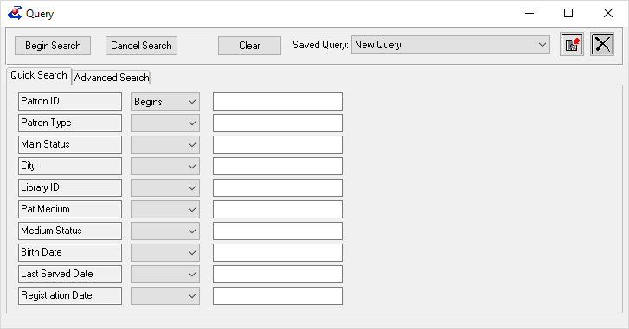
- Fill in as many or few fields as are needed to retrieve the records you need, using the Quick Search tab, Advanced Search Tab, or both.
For more information about building a query, press F1 in the Query window.
- Click Begin Search to run the query, and review the results to ensure that the query is working as intended. Close the Query Results window to return to the Query window.
- If your query includes date ranges that will need to be updated each time the query is run, consider entering a brief description instead of the date.
The query will not work as-is, but this makes it easier to spot what needs to be updated, and ensures that you will not mistakenly reuse an outdated range.

Step Two – Save the query
- Once your query is fully set up, click the Save Query Parameters button to open the Save Query Options window.
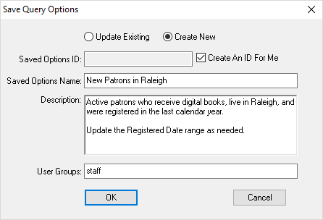
- Each saved query needs to have a unique ID; to generate one automatically, leave the ID field blank and check the box for “Create an ID for me.”
- If desired, enter a description to remind you or inform other users about what the query is for or any fields which will need to be updated before reusing it.
- If User Groups is left blank, only you will be able to see and use the saved query. If you want others to be able to access it as well, enter their group in the User Groups field.
- Click OK to save the query.

Step Three – Load, Edit, or Delete the query
- All queries created by your login or shared to your User Group will be listed in the Saved Query combo-box in the Query window.
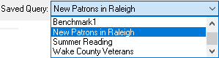
- Select any query from the list to load it to the Query window. It can then be changed as needed and run using the Begin Search button.
- To save any changes made to the query, click the Save Query Parameters button. Ensure that the “Update Existing” option is selected, and click OK.
- To delete a query, ensure that it is selected in the Saved Query field, then click the Delete Query Parameters button.

