Readership & Circulation Report

Process overview
The Readership & Circulation Report is specifically built to pull together all the information you need to pass on to NLS, making the reporting process as quick and painless as possible.
Some of the information the report calls on can change as you continue your work. To get the most accurate numbers possible, run it after completing all of your work on September 30 and before starting any work on October 1. Because of this, it is best to set the report to run through the Batch Manager.

Procedure
- In the Patron Module, open the Readership & Circulation Report from the Reports > Statistics menu.
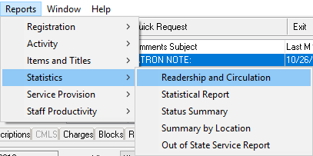
- Enter the date range and other parameters as desired.
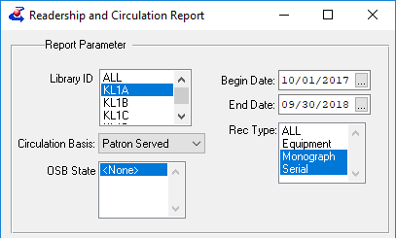

- In the Output Parameters section, select Email and enter the desired address, then click Run As Batch Job. The Batch Schedule window will open.
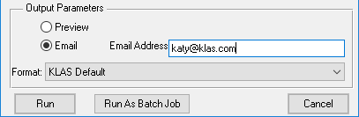
- Leave the Frequency at “One Time,” set the time to 15 minutes before your staff starts working, and the date to October 1 of the current year. Click OK.
- The report window will remain open, but the Readership & Circulation Report is scheduled and will run at the specified date and time.
If you want to check on it, you can open the Batch Manager from the View > Administration menu.
