Re-order Columns

Process overview
Because different libraries and different staff members use information in KLAS differently, we have built in the ability for each user to customize the order of the columns in just about every browse table they encounter.
Browse tables can also be sorted by any column and the Sort Column can be saved following this same procedure.
- Right-click inside any browse table and select Move Columns.
- Click-and-drag any column heading to move it to a new position. Move as many columns as you want.
- Once you are satisfied with the column order, right-click again and select Save Column Positions and Sizes.

Browse Tables
The many browse tables throughout KLAS contain a broad amount of information, including some that you will reference frequently, and some that you may need much more rarely.
A few tables you might consider re-arranging to better suit your needs are found on:
Patron Module: Items Tab, Requests Tab, Book Search Results
Catalog Module: Statistics Tab, Item List

Step One – Activate Move Columns mode
- Open KLAS to a browse table, such as the patron Items list.
- Right-click inside the table and select Move Columns from the context menu.
Once you have selected Move Columns, a checkmark will display beside that option to indicate that this mode is active.
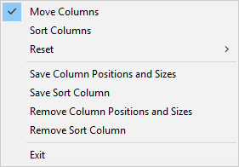

Step Two – Move any column or columns
- Click on any column heading and without releasing the mouse button, drag that column left or right to the desired position. “Drop” the column by letting go of the mouse button in between the columns you want the moved column to be placed between.
- You can also resize columns by dragging the right border.
- If you want to be able to sort the table by column, right-click inside the table again and select Sort Columns mode.
While this mode is active, you can click on any column header to sort the table by that column. Click the same header a second time to reverse the sort order.

Step Three – Save column positions and sizes
- Right-click inside the table and select Save Column Positions and Sizes from the context menu. The information will be saved to your login, and remembered any time you open KLAS to that browse table.
- If you wish your sorting preferences for that table to also be remembered, right-click and select Save Sort Column.

