How to Copy Subscribers
from one Serial to Another

Process overview
When one serial is replaced by another (such as the NLS direct version of Reader’s Digest replacing the APH circulated version), you may wish to copy the subscriber list from one to the other. While this is a manual process, here is a workflow that will make it quick and easy.
- Open the Serials Module and Find the record for the original serial.
- On the Subscribers tab, use the Export to Excel button to get the list of Patrons subscribed to that serial.
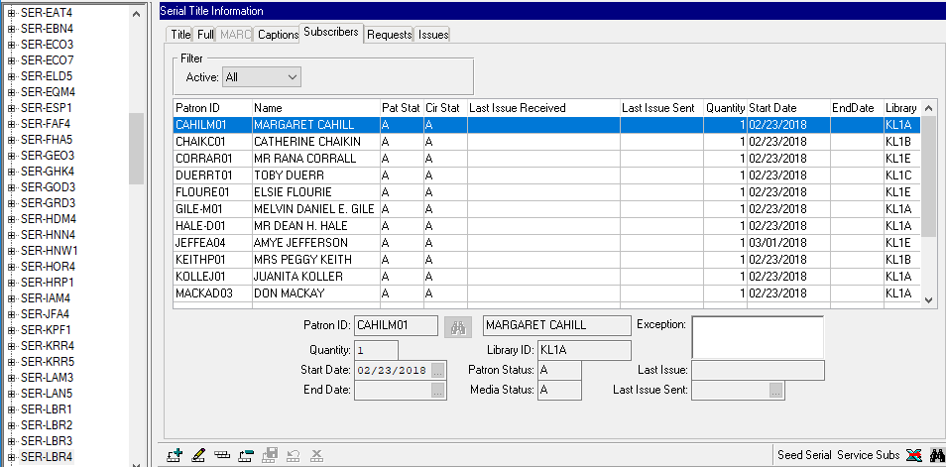
- In Excel, review the list to remove Patrons that are no longer Active, or who may not want the new serial.
  - If you can’t get the list down to fewer than 100 subscribers, please contact KLAS Customer Support for assistance adding them to the new Serial.
- Find the record for the new serial and move to the Subscribers Tab. Use the Add button to create a new subscriber record.
- In the Patron ID field, enter the first Patron ID from your Excel sheet, then Save the record. That Patron now has a subscription to the new magazine.
- You will need to add each Patron from the Excel sheet individually. You can make the process quicker using the keyboard shortcuts Ctrl+N for Add New subscriber and Ctrl+S to Save.

