Book Search – Save Options
The button at the bottom of the Book Search screen is "Save Search Options". This button allows you to set up your search screen the way you like it and save that set up. Once you save it, the system automatically populates that screen the way you want it set up every time you open the Book Search, or when you select a particular search from the Search Type combo box.
Let's say you have a particularly picky patron who only likes one specific subject, with nothing they've checked out in the past year; you could save a search option for that patron's particular search. Set up the Book Search – including your search term (Westerns) and your desired exclusions (No Has-Hads in the past year, no excluded authors) – and press the Save Search Options. Give the search a name, like Barnstable search. The next time you want to find books for that patron, you can select the Barnstable search from the combo box at the bottom right of the screen.
Gotcha: The system will always open Book Search to the most recent search option you have saved. This is great for your favorite, default set-up… but not so good for a specialized search like the Barnstable search above. To keep from always having to select your default search after saving a new one, do the following extra steps:
- Save your new search with a unique name
- Set the Search Type combo box back to your preferred default
- Click Save Search Options and save without changing the name of the search. That default search is now the most recently saved search!
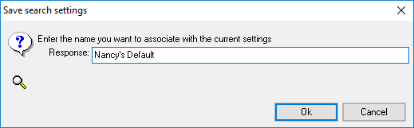

Removing a search option: Okay, you played around and have some extra search options in your combo box that you don't want to have any more. It is possible to remove them using the following steps:
- Open Book Search
- Select the search option you want to delete from the combo box
- In the Searches menu, select Delete Search Options
