Address Validation

Process overview
Address validation ensures that you are entering accurate information, maintains consistent abbreviations, and fills in the +4 zip code extension.
- Update an existing Address record or Add a new one.
- Fill in the street address, city, and state fields, then Save.
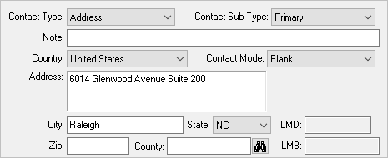
- The Address Compare screen will open, allowing you to review the validated address, with full Zip code and County.
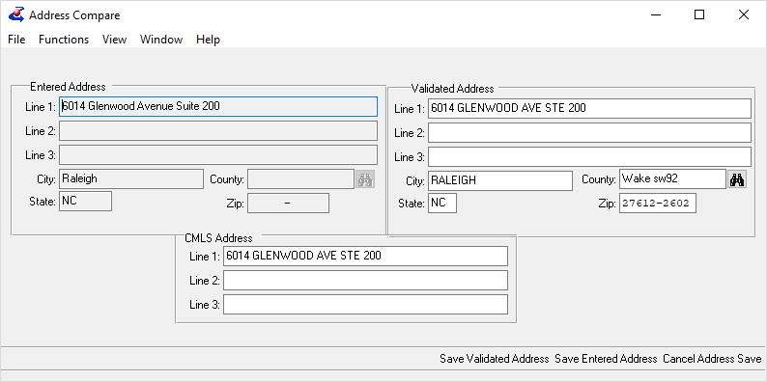
- If minor corrections are needed, make them to both the Validated Address and CMLS Address sections.
- Click Save Validated Address. The record will be saved with the corrected and validated information.
There may be times when KLAS cannot validate an address, such as if the wrong street or city name were entered. In those cases, this window will open instead of the Address Compare screen.
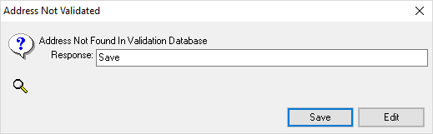
- You may choose to Save the address as-is if you are certain of the information, or if you just want to hold onto it until you can verify the information with the Patron.
- You may choose to Edit the address and correct the error. You will be returned to the open address record.

