How to use SHELF

Process overview
The SHELF project has been updated and improved for use with KLAS v7.7. Much of the process is automatic, but this document will walk you through the whole workflow.
Submitting Titles:
- Add a Monograph or Serial record for the new title and set the Title Status to “STS.”
- Using an FTP client, upload the file to books.klas.com, into the “shelf” folder.
- KLAS will create an EDoc for the new title overnight. At this point, the title is available to download through your OPAC or duplicate using a Scribe.
- The “STS” BibRecs are automatically exported to SHELF overnight. Once a title has been successfully submitted, the Title Status will change to Active in your catalog.
Receiving Titles:
- Once a week, new titles are automatically imported from the SHELF database. They can be downloaded through the OPAC or duplicated using a Scribe right away.
- All cataloguing should be in place, but to review and add Local Subjects if desired, Query for BibRecs with an Add Date of the most recent Friday.

Step One – Add a Record for the New Title
Add a new Monograph record or Serial issue in the appropriate module.
Note: Previously, Serial Issues were added to SHELF as Monograph records, but this is no longer the case! Please enter Serial titles in the Serials Module.

For Monograph Titles:
- Fill in the KLAS ID prefix, or the full KLAS ID if using user-generated IDs.
- Enter the Bibliographic information, including: Author, Publisher, Pub Year, Fiction yes/no, Medium, Language, Grade, Series, and Annotation.
- Enter the recording information, including the Narrator, Alt Length (00 hours, 00 minutes), your library’s name as the Alt Publisher, and the year recorded as the Alt Year.
- Enter local subjects on the BibRec and/or full subject cataloguing on the MARC tab.
- Set the Title Status to “Send to SHELF” or STS.

For Serial Issues:
- If the Issue belongs to a new Serial, create a new Serial record as you would for a Circulating magazine and give it a unique KLAS ID.
Otherwise, select the appropriate existing Serial record.
- If you are also adding physical copies of the Serial:
  - Use the Receive Issue function in the Serials Module to add the new issue.
If the Serial is duplication-only:
  - Go to the Issues tab of the Serial Record. Use the Add Record button to create the new Issue.
- Give the Serial Issue the same name as the zip file containing the recording.

Step Two – Upload the File
- Make sure that the recorded title uses the KLAS ID (plus Issue Name for Serials) as the file name. For example:
- DBC01234.zip
- SER-ABC9-Issue-Name.zip
- In an FTP Client, add a site/profile (first time connecting) or select the books.klas.com profile (subsequent connections).
When adding the site/profile, use these settings:
  - Protocol: SFTP
  - Host: books.klas.com
  - Port: 22
  - User: Library ID (Ex: nc1a)
  - Password: provided by Keystone; you may also be prompted to enter this when logging in
- Drag and drop your locally recorded file into the “shelf” directory. (Your FTP Client may also have keyboard command options for uploading the files without using a mouse.)
For Serials, you may use subfolders to keep your file list more manageable. If you do this, we recommend that you create one folder for each serial, located within the shelf/serials directory. For example:
- /shelf/serials/SER-BOS9/issue-1.zip
Note: For additional information on uploading files to books.klas.com, please see QuickTip – Upload Local Titles.

Step Three – EDoc Creation
A nightly program compares the files on books.klas.com with the records in your catalog. When it finds a match, it creates an EDoc to record the file information.
Once this EDoc has been created, the file will be available for your patrons to download via your OPAC. It will also be available for duplication using a Scribe.

Step Four – Export to SHELF
A nightly program exports all records with a “Send to Shelf” Title Status to the SHELF Database.
Once KLAS receives a confirmation from the SHELF Database that a title has been received, it will update the Title Status to “Active.”

Step Five – Import from SHELF
Once titles have been loaded from submitting libraries into the SHELF Database, Keystone ensures that the cataloguing is ready for distribution to all receiving libraries.
A weekly program imports all of the new titles from the SHELF Database. Currently, this is done on Friday nights.
The titles come in with full MARC cataloguing, an Active Title Status, and a valid EDoc. They will show up on your OPAC with a download link, and will be available for duplication with a Scribe right away.

Step Six – Review new records
You do not need to do anything to the incoming records, but you may choose to review the monograph records and add appropriate Local Subjects, ensuring that they have the chance to get selected by Subject for interested patrons.
You can Query for new monograph SHELF titles in the Catalog Module.
Advanced Search Tab:
- MARC Tag | Tag | Equals | 691
- MARC Tag | Data | Matches | SHELF
- BibRec | Date Added | Is Between | (Friday’s date) | (Friday’s date)
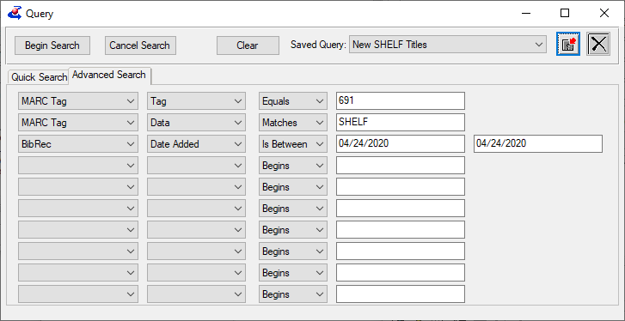
Tip: Save this query so you only need to update the date fields each time!

