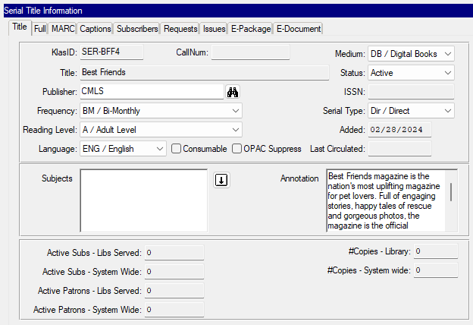

KlasID: SER-BFF4
CallNum:
Medium: DB / Digital Book
Title: Best Friends
Status: Active
Publisher: CMLS
ISSN:
Frequency: BM / Bi-Monthly
Serial Type: Dir /Direct
Reading Level: A / Adult
Language: ENG / English
Consumable: no
OPAC Suppress: no
Annotation: Best Friends magazine is the nation's most uplifting magazine for pet lovers. Full of engaging stories, happy tales of rescue and gorgeous photos, the magazine is the official publication of Best Friends Animal Society, a national nonprofit membership organization dedicated to saving the lives of homeless pets.

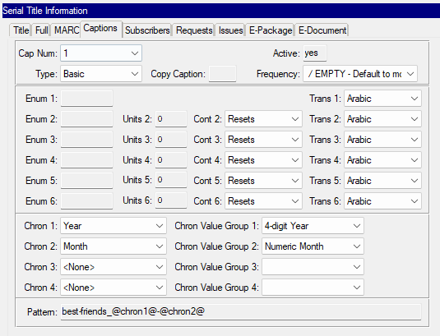
Chron 1: Year
Chron Value Group 1: 4-digit Year
Chron 2: Month
Chron Value Group 2: Numeric Month
Pattern: best-friends_@chron1@-@chron2@

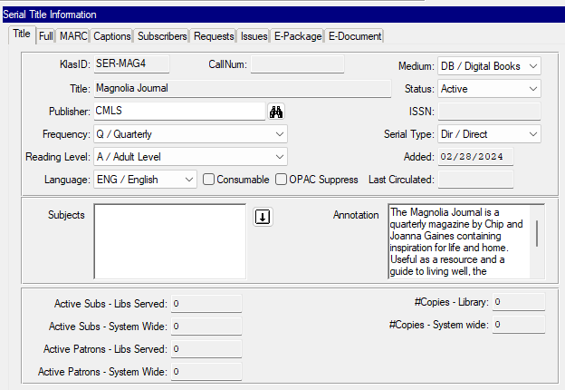
KlasID: SER-MAG4
CallNum:
Medium: DB / Digital Book
Title: Magnolia Journal
Status: Active
Publisher: CMLS
ISSN:
Frequency: BM / Bi-Monthly
Serial Type: Dir /Direct
Reading Level: A / Adult
Language: ENG / English
Consumable: no
OPAC Suppress: no
Annotation: The Magnolia Journal is a quarterly magazine by Chip and Joanna Gaines containing inspiration for life and home. Useful as a resource and a guide to living well, the Magnolia Journal contains stories, recipes, tips, and useful information you will refer back to again and again.

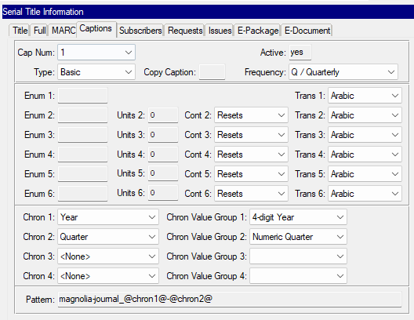

Chron 1: Year
Chron Value Group 1: 4-digit Year
Chron 2: Quarter
Chron Value Group 2: Numeric Quarter
Pattern: magnolia-journal_@chron1@-@chron2@

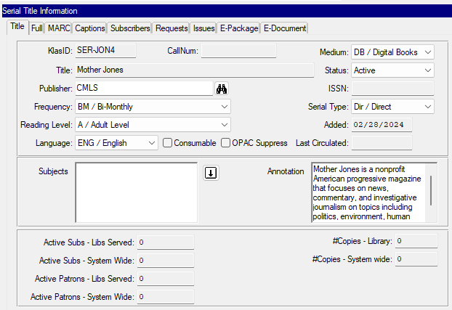
KlasID: SER-JON4
CallNum:
Medium: DB / Digital Book
Title: Mother Jones
Status: Active
Publisher: CMLS
ISSN:
Frequency: BM / Bi-Monthly
Serial Type: Dir /Direct
Reading Level: A / Adult
Language: ENG / English
Consumable: no
OPAC Suppress: no
Annotation: Mother Jones is a nonprofit American progressive magazine that focuses on news, commentary, and investigative journalism on topics including politics, environment, human rights, health and culture.

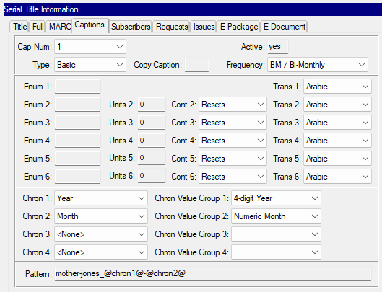
Chron 1: Year
Chron Value Group 1: 4-digit Year
Chron 2: Month
Chron Value Group 2: Numeric Month
Pattern: mother-jones_@chron1@-@chron2@

