How to Upload Local Titles
  - For Scribe

Process overview
We provide books.klas.com as a standardized depository for local files, allowing you to distribute locally recorded books, serials, and instructional files to all of your Scribe units at once, and ensuring that these files will not be lost if your Scribe has a memory failure.
You will need to use an FTP Client to upload the files. WinSCP and FileZilla are popular choices, but any FTP Client that is provided or allowed by your parent agency is fine.
- Create a catalog record in KLAS for the local title, and set the appropriate Medium and Language.
- Place the recording in a zipped folder, and use the KLAS ID as the filename (for example, DBC01234.zip). This will allow KLAS to match the record and the file with an eDoc.
- In your FTP Client, add a site/profile (first time connecting) or select the books.klas.com profile (subsequent connections).
When adding the site/profile, use these settings:
  - Protocol: SFTP
  - Host: books.klas.com
  - Port: 12360
  - User: Library ID (Ex: nc1a)
  - Password: provided by Keystone; you may also be prompted to enter this when logging in
Example set-up (your program may look different):
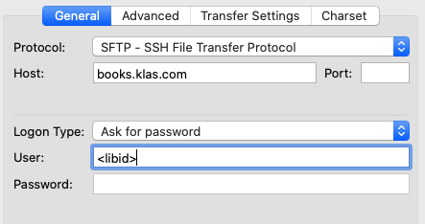

- Once connected to books.klas.com, drag and drop your locally recorded files into the appropriate directory. (Your FTP Client may also have keyboard command options for uploading the files without using a mouse.)
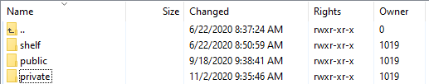
- Use the “shelf” folder for titles that should be shared out to other libraries participating in SHELF.
- Use the “public” folder for titles that patrons should also be allowed to download from your WebOPAC.
- Use the “private” folder for titles that should not be included on your WebOPAC, such as announcements or instructions.
Depending on the number of files you have and your internet upload speed, uploading a large batch of titles could take a while and may affect your overall bandwidth in your building. Try uploading files overnight or over the weekend to avoid any slowness.
- Once the files are uploaded to this depository, they will be available for duplication the following day. In the meantime:
- Your Scribe Mini(s) will download new files overnight, ensuring that these titles will be available in their local storage for duplication the following day.
- A process will run overnight to pair up the files to the matching BibRecs in KLAS, and automatically create the EDocs.

