Front Desk Service Manual
  - For KLAS v7.7 with Scribe
Contents
Logging Into KLAS 1
Finding a Patron 2
Patron Maintenance 3
Change a Patron’s Address 3
Change a Patron’s Preferences 4
Magazine Subscriptions 5
Adding Requests 6
Adding Requests by Book Number 6
Adding Requests by Title and/or Author 7
Converting a Patron to Duplication 8
Creating a Duplication Order 10
From the Service Queue 10
From Quick Request 11
Using the Scribe 12
Using a new cartridge 12
Re-using a patron’s previous cartridge 12
Checking In Cartridges 12
The Scribe WebMonitor 13

Logging Into KLAS
Never share a log-in with other staff members unless your administrator directs you to use a shared account, such as a dedicated “Front Desk” account.
- Open KLAS. If you are notified that an update is ready, use the Update button to apply the update and continue to the Login screen.
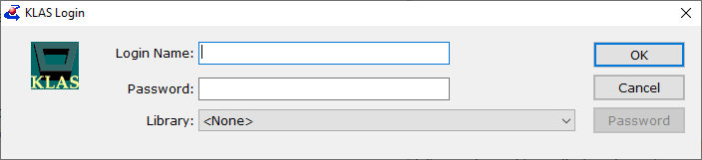
- Enter your username in the first field. Once you either Tab or click into the next field, the Library will be filled in automatically.
- Enter your password, then press Enter or click the Ok button. The KLAS Desktop will open.
- Select either the Front Desk module or the Patron module.
  - Front Desk allows for simple patron service tasks and checking materials out directly to the patron.
  - Patron includes additional patron service functions and allows for maintenance of a patron’s automatic service, but not direct checkout of physical materials.
Note: it sometimes takes a little while for all the information to be fully loaded into the screen as the module opens. Do not try to perform any tasks in a module until the window has finished loading.

Finding a Patron
- In either the Front Desk or Patron module, use the Find button or press Ctrl+F to open the Find Patron tool.
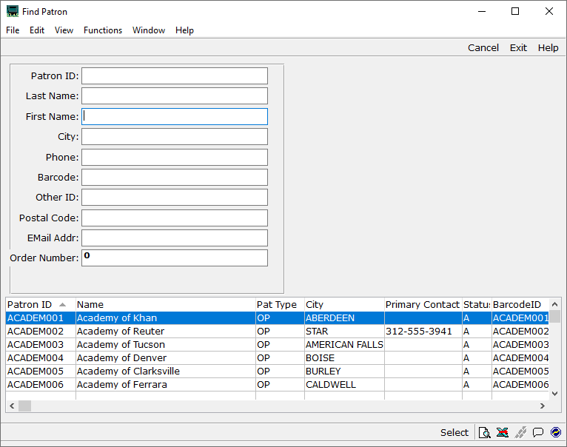
- You can use as many or as few of the search fields as you need.
  - All fields use a Begins search, meaning that they will match from the beginning of the field. Searching for Last Name: Johns will return “Johnson” and “Johnston,” but not “Smith-Johnson”
  - Punctuation can be omitted from the Phone field. Search for 9197821143, not 919-782-1143.
  - Every time you Tab or click into a new field, or press enter, the search criteria so far will be applied to the list of records in the bottom of the window.
- When you see the patron you are looking for in the list at the bottom of the window, double-click the row, or select it and press the Space Bar to open the patron’s record.
If only 1 patron record matches the search, pressing Enter will also open the record.

Patron Maintenance

Change a Patron’s Address
- In the Front Desk or Patron module, Find the Patron record. (Ctrl-F)
- Switch to the Contact tab. (Alt-7 in Front Desk; Alt-2 in Patron)
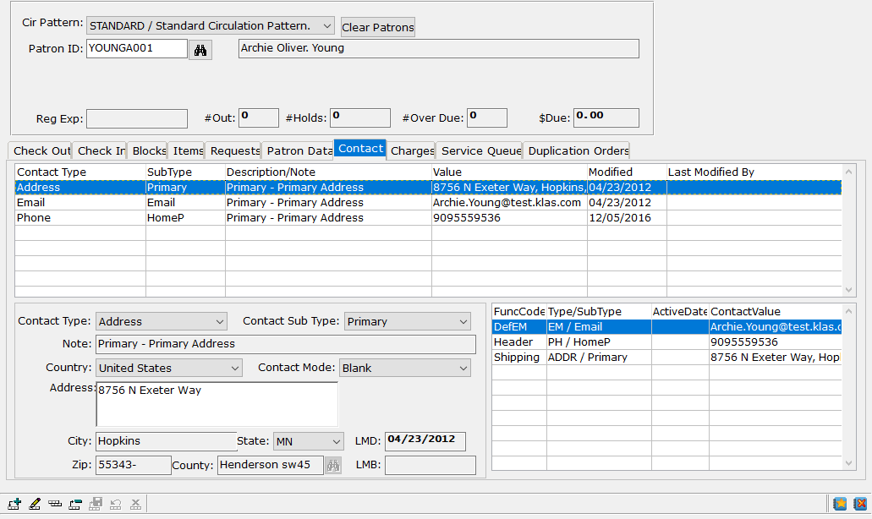
- To correct an existing address, select it in the top browse and use the Update record button. (Ctrl-o)
  - Make the desired corrections, then Save changes. (Ctrl-s)
OR - To add a new address, use the Add record button. (Ctrl-n)
  - Select the Address contact type, and the appropriate Sub Type (such as Primary or Temporary).
  - Enter the address, city, and state.
  - Save the new record. (Ctrl-s)
  - The Address Validation record will pop up. Ensure that it found the correct information, then Save Validated Address.
  - A pop up will ask whether the new address should be made primary; select Yes.
The new address is now saved. It will be displayed in the patron header and future books and magazines will be sent to the new or corrected address.

Change a Patron’s Preferences
KLAS uses a patron’s Preferences to send books automatically or to fill their Service Queue for Duplication.
- In the Patron module, Find the Patron record. (Ctrl-F)
- Switch to the Preference tab. (Alt-4)
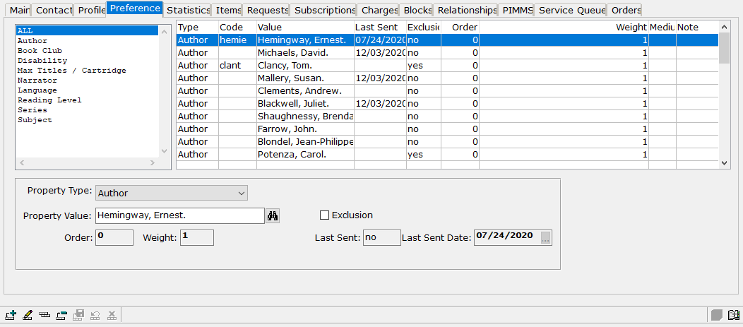
- To add a preference, use the Add Record button. (Ctrl-n)
  - Select the appropriate Property Type, such as Author or Subject.
  - Enter the preference in the Property Value field.
If you are not sure on the exact spelling, enter the first part and press tab to perform a Begins search, or use the Find button beside the field.
  - To indicate that the patron does not want books matching that property, check the Exclusion box.
Note: Some properties, such as Language and Reading Level must match. As such, no Exclusions can be added for those properties.
  - When you are finished, use the Save button. (Ctrl-s)
- To remove a preference, use the Delete Record button. (Ctrl-d)

Magazine Subscriptions

Adding a Magazine Subscription
- In the Patron module, Find the Patron record. (Ctrl-F)
- Switch to the Subscriptions tab. (Alt-8)
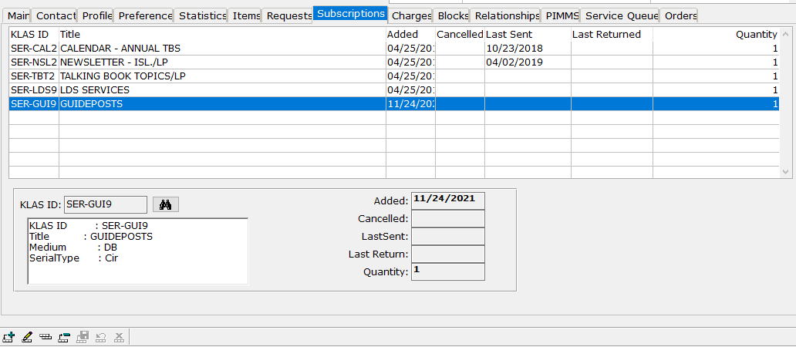
- Use the Add record button to create a new subscription. (Ctrl-n)
- Enter the Serial KLAS ID if known, or use the Find button to enter the Serial by name.
- Save the new subscription. (Ctrl-s) The added date will be filled in automatically.

Canceling a Magazine Subscription
- In the Patron module, Find the Patron record. (Ctrl-F)
- Switch to the Subscriptions tab. (Alt-8)
- Select the unwanted magazine in the browse table.
- Use the Delete record button. (Ctrl-d)
OR Use the Update record button, and add today’s date to the Cancelled field. Save the change. (Ctrl-s)

Adding Requests

Adding Requests by Book Number
- In the Patron or Front Desk module, Find the Patron record. (Ctrl-F)
- Open the Quick Request function. (Ctrl-T)
The screen will open with the patron already selected. It will default to Service Queue for patrons getting Duplication and to Request for everyone else.
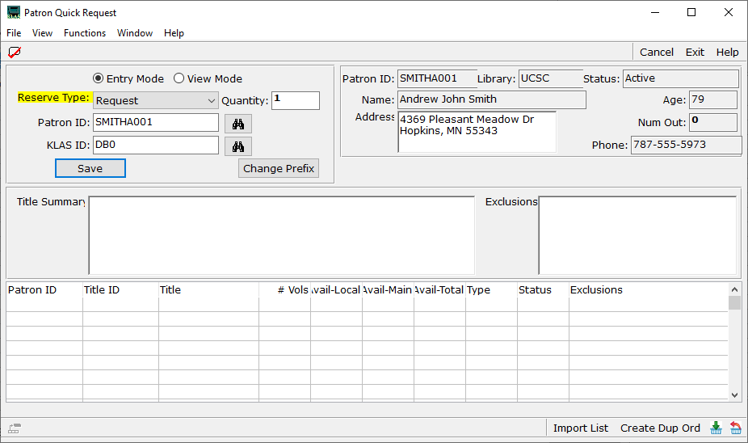
- Type in the KLAS ID and press Enter. The title information will be displayed and the title will be added to the patron’s record.
  - If you need to change the pre-filled prefix (usually DB0 or just DB), use the Change Prefix button.
  - If a patron has exclusions against a title, they will be displayed.
  - If a patron no longer wants a title or if a number was mis-typed, use the Delete record button. (Ctrl-d)
  - If all titles listed should be added to a Duplication cartridge, use the Create Dup Ord button or select Create Duplication Order from the Functions Menu. (See Creating a Duplication Order From Quick Request on page 11 for more info)
- When all numbers have been added for that patron, close Quick Request. (Alt-x)

Adding Requests by Title and/or Author
- In the Patron or Front Desk module, Find the Patron record. (Ctrl-F)
- Open the Book Search function. (Ctrl-B)
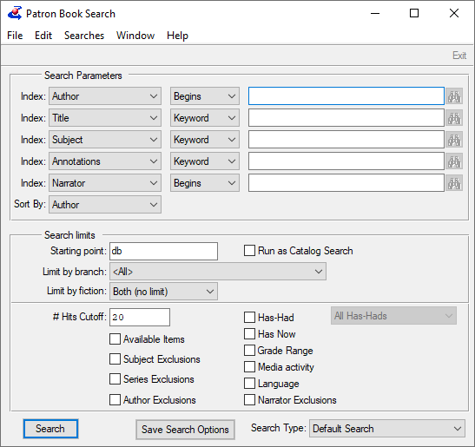
- Use the Search Parameters to enter the search criteria, such as author name or title. If the Index you need is not listed, select it from the first drop-down on any row.
- Select any desired search limits, such as Available Items (to show only results that are available or Has-Had (to show only results the patron has not had before).
- Use the Search button when all criteria have been entered. The Search Results screen will open.
- Select the desired result or results from the Search Results browse table, then use the bottom toolbar to Assign (Ctrl-g), add a Request (Alt-r), add a Reserve (Alt-v), or add to Service Queue (Assign menu).
- After closing the Search Results window, you can enter new criteria to search again, or close the Book Search window if you are finished. (Alt-x)

Converting a Patron to Duplication

Step One – Open the Add Service Queue window
- In the Front Desk or Patron module, Find the Patron record (Ctrl-F) and navigate to the Service Queue tab. (Front desk Alt-8 or Patron Ctrl-3)
- From the Functions menu, open Service Queue, then select Add Service Queue. Or, use the keyboard command Ctrl+L. The Add Service Queue window will open.

Step Two – Service Queue options and considerations
The Patron ID and Patron Name fields are read-only, allowing you to confirm that the Service Queue is being created for the intended patron.
- Medium – the medium for this Service Queue; leave it set to DB for Digital Book duplication  - Delivery Method – how these titles will be delivered to the Patron; leave it set to Duplication  - NS Cutoff and NS Shipment – these values will update the current Profile settings. Once a patron has a Service Queue, KLAS will only count duplication cartridges towards their cutoff. | 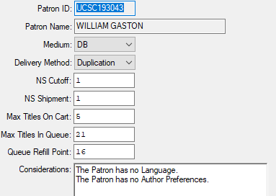  a.  b.  c.  d.  e.  f.  g.
- Max Titles On Cart – the most titles that KLAS will attempt to place on one cartridge.
- Max Titles In Queue – the number of titles that KLAS will fill or refill the queue to meet.
- Queue Refill Point – when the number of titles in the Service Queue drops below this number, Nightly processes will refill the queue back to Max.
Note: This should never be smaller than the patron’s “Max Titles On Cart” or they may receive cartridges with fewer titles than expected.
- Considerations –check here for notification of anything that may prevent this Patron from receiving automatic service.

Step Three – Fill method and Create Queue
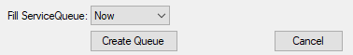
h.
i.
- Fill Service Queue – this combo box indicates when the new Service Queue will be initially filled with titles.
Now will create the queue immediately. This is a good choice if you want to review the Queue as soon as it has been created.
In Batch will tell KLAS to fill the queue in the background, allowing you to continue to work in the meantime.
Don’t Fill Queue will not add any titles to the queue at this time. This is a good choice if you want to add specific titles before running the automatic process.
After any requests have been added, the rest of the Service Queue can be filled manually using the Fill button on the Service Queue tab. Otherwise, Nightly processes will fill the queue overnight.
- Create Queue – once you have reviewed all of the other fields, use this button to create the patron’s Service Queue.
The patron will be switched to Duplication Service, and their Service Queue will be filled as appropriate.

Results
Once the patron has a Service Queue, they will no longer receive Physical circulation.
Any traditional cartridges they have checked out will no longer count towards their NS Cutoff.
Their header and Profile tab will have indicators to show that they are now Duplication patrons. (You will need to refresh the record or leave and come back to see the change.)

Creating a Duplication Order

From the Service Queue
- In the Front Desk or Patron module, Find the Patron record. (Ctrl+F)
If the patron is not already set up for duplication, instructions are in the section Converting a Patron to Duplication on page 8.
- Navigate to the Service Queue tab (Alt-8 or Ctrl-3) and make sure the desired titles are listed at the top of the patron’s queue.
  - Use the Add Record button or Ctrl-a to add requests one at a time, or
  - Use the Add to Service Queue function in Book Search Results.
  - Move titles in the queue with the green arrow buttons or ctrl-alt-arrow keys.
- Use the Functions - Service Queue menu to select Create Dup Order from Queue, or use Ctrl-Alt-D. The Create Duplication Order from Queue screen will open.
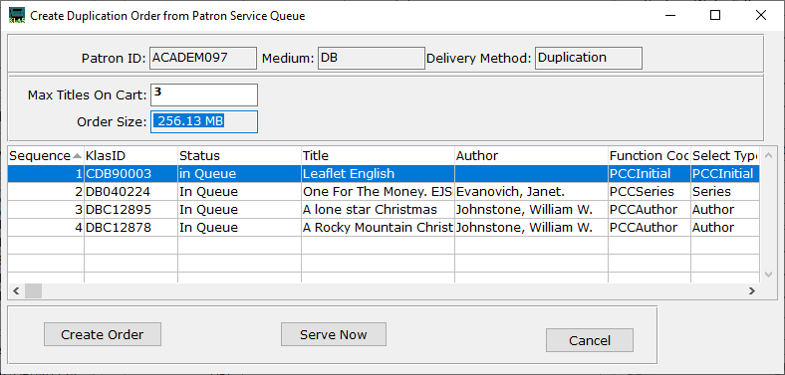
- The screen will load with the patron’s usual Max Titles Per Cartridge, but you can set the number of titles for this order by typing in the desired number and pressing Tab.
Any automatic leaflet or instructions file will be listed, but not count towards the max.
- When you are satisfied with the list of titles, select Serve Now. This will create the Duplication Order and Assign it to the patron right away.
- Navigate to the patron’s Orders Tab (Alt-9 or Ctrl-4) and select the new order.
- Use the Walk-In button or select Walk-In from the Functions menu.
- The Print Mail Card window will open, with the criteria in place to print only the Mail Card for the selected order. Check that the stock and printer are set correctly.
- Select Print. The Mail Card will print to the selected printer, ready for duplication.

From Quick Request
- In the Front Desk or Patron module, Find the Patron record. (Ctrl-F)
If the patron is not already set up for duplication, instructions are in the section Converting a Patron to Duplication on page 8.
- Open Quick Request using the button or Ctrl-T.
- The Reserve Type will default to Service Queue. Enter the desired KLAS IDs.
- Once the Requests have been entered, select the Create Dup Ord button or use the Functions Menu to select Create Duplication Order.
A confirmation screen will open. The confirmation screen will list the contents of the order, which will be all titles currently in the Quick Request window, along with the order size.
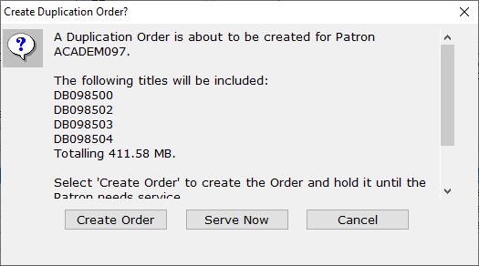
- Review that everything looks correct, then select Serve Now. This will create the Duplication Order and Assign it to the patron right away.
- Navigate to the patron’s Orders Tab (Alt-9 or Ctrl-4) and select the new order.
- Use the Walk-In button or select Walk-In from the Functions menu.
- The Print Mail Card window will open, with the criteria in place to print only the Mail Card for the selected order. Check that the stock and printer are set correctly.
- Select Print. The Mail Card will print to the selected printer, ready for duplication.

Using the Scribe

Using a new cartridge
- See Creating a Duplication Order on Page 10 to make an order to be Duplicated. You will need the Mail Card with a duplication barcode on it.
- At the Scribe, scan the Duplication Mode barcode.
- Scan the duplication barcode on the Mail Card. One of the Scribe’s cartridge ports will light up white, and Scribe will announce which port is waiting for a cartridge.
- Plug any available cartridge into the indicated cartridge port. The light will turn blue, and the Scribe will announce that copying has started.
Note: If you are duplicating multiple orders at once, make sure to track which mail card went with which cartridge port.
- When the light turns green and the Scribe announces that the port is completed, the cartridge has been successfully duplicated and checked out. It can be given to the patron or put in the mail.

Re-using a patron’s previous cartridge
- If the patron wants specific books, see Creating a Duplication Order on Page 10; otherwise, you can let KLAS build an order for them automatically.
- At the Scribe, scan the Walk-In Mode barcode.
- Plug the patron’s previous cartridge(s) into any cartridge port. The light will turn blue, and the Scribe will announce that that copying has started.
Note: If you are duplicating multiple cartridges at once, make sure to track which cartridge went with which patron.
- When the light turns green and the Scribe announces that the port is completed, the cartridge has been successfully duplicated and checked out. It can be returned to the patron.

Checking In Cartridges
If you are going to re-use a cartridge right away, you do not need to check it in.
To check in a cartridge that will not be going right back out to a patron:
- At the Scribe, scan the Check-In Mode barcode.
- Plug the cartridge or cartridges to check in into any cartridge ports.
- When the light turns green and the Scribe announces that the port is completed, the cartridge has been successfully checked in and can be returned to storage.

The Scribe WebMonitor
More information about the status of the Scribe and all cartridge ports, including information about any errors, can be found on the Scribe WebMonitor.
This webpage does not include any identifiable patron information, so it can be accessed from any device with internet access.
- In any web browser, go to your library’s WebOPAC.
- At the end of the WebOPAC URL, replace “index.jsf” with: /PCC/
For example: https://bils.klas.com/pcc/
- If your library system has multiple Scribes, use the drop-down at the top of the page to select the system to check.
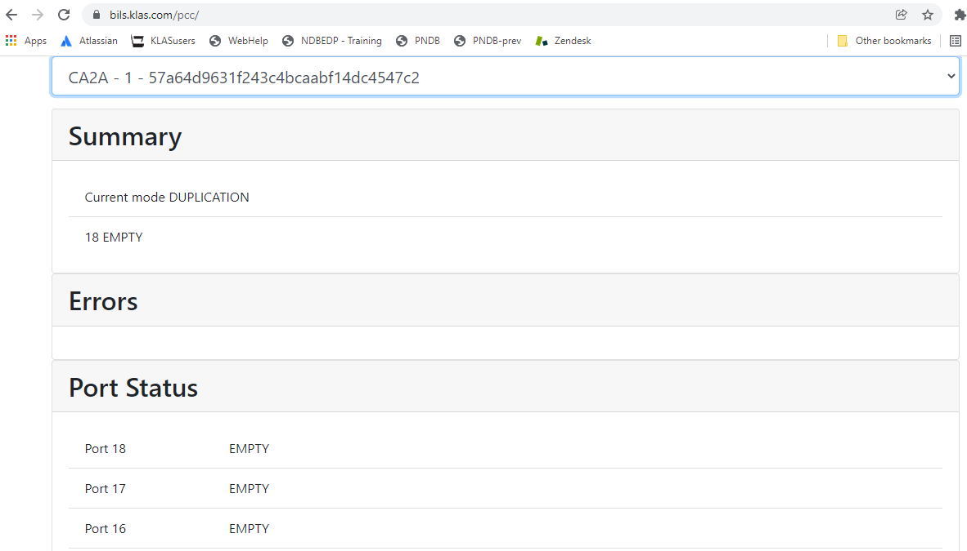
- The Summary section includes the Scribe’s current mode.
- The Errors section includes the full text of any current errors.
- The Port Status section includes the status of every cartridge port in order.
  - The first column is the port number.
  - The second is a brief status, such as Complete_Mail for a completed, ready-to-mail cartridge.
  - The third column has the full text of the status, such as an Error message.
Note: If you encounter an unfamiliar error, the Scribe Help Page on KLASusers.com includes troubleshooting information for common Scribe errors. Find it at:
https://klasusers.com/knowledgebase/scribe-help
or using the Duplication on Demand tag in the Knowledge Base.

