How to Merge Queries

Process overview
Queries in KLAS make it easy to find records that meet certain criteria. Unfortunately, it can be harder to search by what isn't there. Computer logic is just not very good at that kind of thinking... but now, there is a way to combine two queries in KLAS, allowing you to:
- Combine the lists of records that meet different sets of criteria, and eliminate duplicates (i.e. match X and/or Y)
- Find records that are included in two different query sets (i.e. match X and Y)
- Subtract one Query from another (i.e. match X but do not match Y)
This document will first give the steps to combine any two queries, then cover several specific examples to help you practice and learn when this process can be helpful.
- Merge any two Queries
  - Run your first Query (called Query A) in either the Patron or Catalog Module.
  - Open any Query result to save the query set.
  - Run your second Query (Query B) in the same module, and open any result.
  - From the Query Menu, select Merge Queries.
  - Select Query A and Query B in the combo-boxes.
  - Set your Merge Type. The results can be opened as a new query set or exported to Excel.
- Find Active Patrons that do not have an Active DB Medium.
- Find the oldest and/or longest-registered Patrons.
- Find Titles with content notices in the Annotation that do not have the matching Local Subject heading.
- Other Possibilities

A – Merge Any Two Queries

Query A
- Open the Query screen from the Query Menu or icon in either the Patron or Catalog Module.
- Enter the desired search restrictions on the Basic Tab, Advanced Tab, or both. We’ll call this Query A.
- Select Run, and browse the results to make sure the Query worked as you expected.
- Select any result and double-click or press Enter to open the query set to that record. Opening the query set will also save Query A to your recent queries list.
Note: If you do not open the query set, the query will be discarded and you will need to run it again.

Query B
- Run your second Query (Query B) in the same module. This is the query for results to be added to, compared with, or subtracted from Query A.
- Again, open any result to save Query B to your recent queries list.

Merge
- From the Query Menu, select Merge Queries.
- Use the combo-box to select Query A, probably your second-most-recent query. The full query details will be listed, allowing you to confirm that you selected the right query.
- Use the next combo-box to select Query B, probably your most recent query.
Note: When you are combining or comparing queries, the query order does not matter; however, for subtracting a query, make sure that you have A and B in the correct order.
- Set your Merge Type:
  - In A not B (Find records that do not have certain information)
  - In Both A and B (Find records that are included in two different query sets)
  - In either A or B (Find records that are in either of two different query sets)
- The combined results will be counted at the end of the Merge line, and displayed in the browse table. They can then be opened as a new query set and/or exported to Excel.
Confused? Don’t worry!
Browse through the following examples—or even better, pick a couple to try. It will make more sense the more you do it.
B – Find Active Patrons that do not have an Active DB Medium.
Queries have the option to search for fields that “do not equal” a certain value. However, this will only function correctly if that field can only occur once in the record, otherwise, it will find any occurrence where the field does not equal that value.
For example, you can query for Patrons whose “Main Status does not equal Active,” because patron records can only have one Main Status. On the other hand, if you query for “Patron Medium does not equal DB,” it will return all records that have another medium in addition to DB, because that medium does not equal DB. Furthermore, it will not return records without any Patron Mediums, because there is nothing for it to compare to the search value.
This is a matter of computer logic not working quite like human logic. To get the computer to understand what you’re looking for, break it down a little further to “find Active Patrons, then subtract all patrons with an Active DB Medium.”
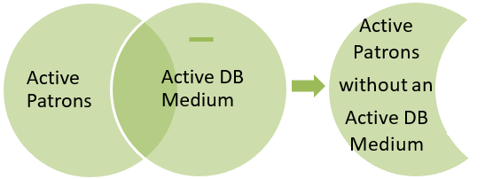

Query A
Use the first query to define the set of records you want to check for an Active DB Medium. In this case, that’s PA / Individual Patrons with a Main Status of Active.
To keep the query small, I’ve also restricted the query to patrons that live in Raleigh. You could use a city in your own state, a range of last names, or just leave it open to all active patrons.
Query (Basic Tab):
- Patron Type | Equals | PA
- Main Status | Equals | A
- City | Matches | Raleigh
Run the query, then double-click or press enter on any query result to open the query set.

Query B
Use the second query to define what you want to subtract from Query A, in this case, records with an Active DB Medium.
Because this is being subtracted from the first query, it does not matter whether or not you include the same restrictions that you use in Query A. Including them can make the query run a little faster, so it can make sense when checking for something very common, like an Active DB Medium.
Query (Basic Tab):
- Patron Type | Equals | PA
- Main Status | Equals | A
- City | Equals | Raleigh
- Pat. Medium | Equals | DB
- Medium Status | Equals | A
Run the query, then double-click or press enter on any query result to open the query set.

Merge
From the Queries Menu, open Merge Queries. Set Query A (probably your second-most-recent query) and Query B (your most recent query). Review the query details listed in the data fields to ensure that you have selected the correct query sets.
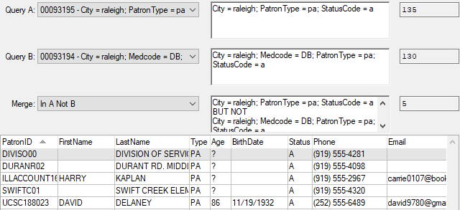

C – Find the oldest and/or longest-registered Patrons.
As you add lines to any query, KLAS will always return only the records that match all of the listed criteria. However, there are times when you want results that are either X or Y. If both X and Y are in the same field, you can probably use an “In” query operator and list both options. If they are not, you will need to run them as separate queries.
In this example, if you tried to search for both your oldest and your longest-registered patrons at once, you would only get the patrons that are in your specified age range AND in your registration date range. Instead, do two separate queries to find first one, then the other.
You could then run two sets of mailing labels, but you would probably end up with duplicates—to avoid that, merge the queries using the Either A or B type.
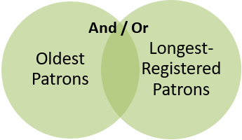

Query A
To find the oldest patrons, use the “is between” operator to define the range you are looking for. The following range will find all patrons that are 100 years old as of when this document was written. The query is also narrowed down to active, individual patrons.
Query (Basic Tab):
- Patron Type | Equals | PA
- Main Status | Equals | A
- Birth Date | Is Between | 01/01/1800 | 06/17/1919
Run the query, then double-click or press enter on any query result to open the query set.

Query B
To find the longest-registered patrons, use the Registration date. The following range will find all patrons that have been registered for 25 years or more as of when this document was written.
For this type of merge, you must include any desired restrictions on both queries.
Query (Basic Tab):
- Patron Type | Equals | PA
- Main Status | Equals | A
- Registration Date | Is Between | 06/17/1994 | 06/17/2019
Run the query, then double-click or press enter on any query result to open the query set.

Merge
From the Queries Menu, open Merge Queries. Set Query A and Query B; for this merge type, the order does not matter. Review the query details listed in the data fields to ensure that you have selected the correct query sets.
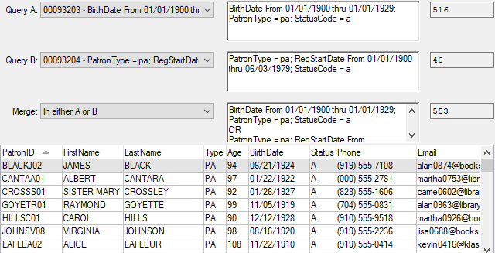
Note: You may notice that the total number of records in the merged query (553) is lower than the sum of queries A and B (556). That’s because three records were included in both query sets—but they are only listed once in the merged query set.

D – Find Titles with content notices in the Annotation that do not have the matching Local Subject heading.
Merging queries can also be very useful in the Catalog Module. Just as querying for Patron Medium information that “does not equal” a certain value does not usually work (see Example B), querying for Local Subjects that “do not equal” a certain value will not work because Titles almost always have multiple subjects. KLAS looks at those subjects individually and compares each one to the query parameters, rather than looking at the list as a whole and checking for what isn’t there. Using merge queries, however, you can tell it what records to subtract from your original set.

Query A
Query for Active DB titles with “Strong Language” in the annotation. This is the set of all titles that you will “check” for a matching Local Subject heading.
Query (Basic Tab):
- Medium | Equals | DB
Advanced Tab:
- BibRec | Title Status | Equals | A
- BibRec | Annotations | Matches | Strong Language
Run the query, then double-click or press enter on any query result to open the query set.

Query B
Query for titles with a Local Subject heading for “Contains Strong Language.” This is the list to subtract from the full set of titles.
You do not need to include the restrictions from the original query (DB medium, Active status), but they can help speed up the query.
Query (Basic Tab):
- Medium | Equals | DB
Advanced Tab:
- BibRec | Title Status | Equals | A
- Heading | Type | Begins | Subj
- Heading | Code | Equals | ST
Note: your heading code may be different, depending on your cataloging. For this example, use the subject code for your “Contains Strong Language” exclusion. If you have multiple possibilities (such as Contains Some... and Contains Explicit...) use “In” instead of “Equals” and list them, such as: ST,XST
Run the query, then double-click or press enter on any query result to open the query set.

Merge
From the Queries Menu, open Merge Queries. Set Query A and Query B; making sure that A is your query against the Annotations (the set of records to check) and B is the query for the Heading (the information that may be missing).
Review the query details listed in the data fields to ensure that you have selected the correct query sets.

