To streamline the process of adding bestseller subject headings to completed KLAS records, we can access the bookshare.org top 10 fiction and non-fiction titles from the New York Times list each month. Rather than duplicating effort by repeatedly checking records for titles listed week after week, these lists round up the titles without repeating them.
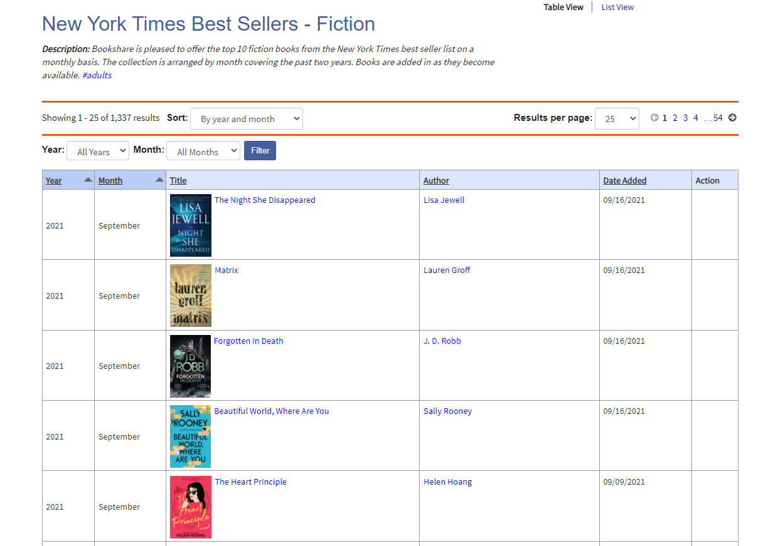

Fiction: https://www.bookshare.org/browse/collection/194327
Non-Fiction: https://www.bookshare.org/browse/collection/194350
Children’s: https://www.bookshare.org/browse/collection/194353

